**Russian-Chinese international scientific school**

**“Superconducting functional materials for advanced quantum technologies'24”**

September 23-27, 2024

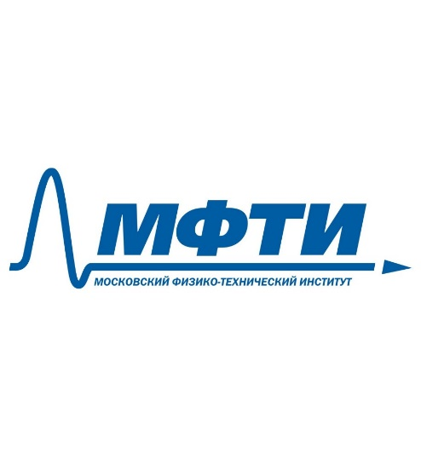  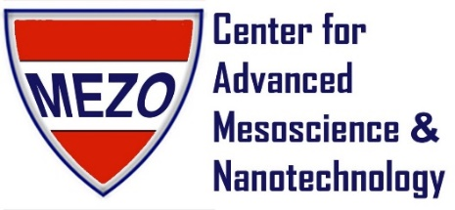

**Organized By：**

* Center for Advanced Mesoscience and Nanotechnology, Moscow Institute of Physics and Technology (CMN MIPT)
* School of Physics, Beijing Institute of Technology (BIT)

**Dolgoprudny, Russia**

**Program**

|  |  |  |  |
| --- | --- | --- | --- |
| **Monday, September 23, 2024**  **Location: Room 119, Main Building, MIPT** | | | |
| **Session Chair:** | | | |
| 09:00-10:30 | Opening Ceremony. | 1st lecture | |
| 10:30-11:00 | **Coffee Break & Take Photos** | | |
| 11:00-12:30 |  | 2nd lecture | |
| 12:30-14:00 | **Lunch at MIPT Cafe** | | |
| 14:00-15:30 |  | | 3rd lecture |

|  |  |  |  |
| --- | --- | --- | --- |
| **Tuesday, September 24, 2024**  **Location: Room 119, Main Building, MIPT** | | | |
| **Session Chair:** | | | |
| 09:00-10:30 |  | 4th lecture | |
| 10:30-11:00 | **Coffee Break** | | |
| 11:00-12:30 |  | 5th lecture | |
| 12:30-14:00 | **Lunch at MIPT Cafe** | | |
| 14:00-15:30 |  | | 6th lecture |

|  |  |  |  |
| --- | --- | --- | --- |
| **Wednesday, September 25, 2024**  **Location: Room 119, Main Building, MIPT** | | | |
| **Session Chair:** | | | |
| 09:00-10:30 |  | 7th lecture | |
| 10:30-11:00 | **Coffee Break** | | |
| 11:00-12:30 |  | 8th lecture | |
| 12:30-14:00 | **Lunch at MIPT Cafe** | | |
| 14:00-15:30 |  | | 9th lecture |

|  |
| --- |
| **Thursday, September 26, 2024**  **Excursion Day** |

|  |  |  |  |
| --- | --- | --- | --- |
| **Friday, September 27, 2024**  **Location: Room 119, Main Building, MIPT** | | | |
| **Session Chair:** | | | |
| 09:00-10:30 |  | 10th lecture | |
| 10:30-11:00 | **Coffee Break** | | |
| 11:00-12:30 |  | 11th lecture | |
| 12:30-14:00 | **Lunch at MIPT Cafe** | | |
| 14:00-15:30 |  | | 12th lecture |
| 15:30-16:30 | **Poster Session** | | |
| 16:30-17:00 | **Closing ceremony** | | |

**Poster Session**

|  |  |
| --- | --- |
| **Friday, September 27, 2024**  **Time：17:00-18:00**  **Location: the 2nd floor of Concert Hall** | |
| **Poster Session Chair:** | |
|  |  |
|  |  |
|  |  |
|  |  |
|  |  |
|  |  |
|  |  |
|  |  |
|  |  |
|  |  |
|  |  |
|  |  |
|  |  |
|  |  |
|  |  |
|  |  |
|  |  |
|  |  |

The school was supported by the project “Superconducting functional materials for advanced quantum technologies” (No.23-72-30004) - Grant from the Russian Science Foundation.

**Notes**

|  |
| --- |
|  |
|  |
|  |
|  |
|  |
|  |
|  |
|  |
|  |
|  |
|  |
|  |
|  |
|  |
|  |
|  |
|  |
|  |
|  |
|  |
|  |

**Notes**

|  |
| --- |
|  |
|  |
|  |
|  |
|  |
|  |
|  |
|  |
|  |
|  |
|  |
|  |
|  |
|  |
|  |
|  |
|  |
|  |
|  |
|  |
|  |

**Notes**

|  |
| --- |
|  |
|  |
|  |
|  |
|  |
|  |
|  |
|  |
|  |
|  |
|  |
|  |
|  |
|  |
|  |
|  |
|  |
|  |
|  |
|  |
|  |

**Notes**

|  |
| --- |
|  |
|  |
|  |
|  |
|  |
|  |
|  |
|  |
|  |
|  |
|  |
|  |
|  |
|  |
|  |
|  |
|  |
|  |
|  |
|  |
|  |

**Notes**

|  |
| --- |
|  |
|  |
|  |
|  |
|  |
|  |
|  |
|  |
|  |
|  |
|  |
|  |
|  |
|  |
|  |
|  |
|  |
|  |
|  |
|  |
|  |